# Brainstorm

**TIP**

You can select a sticky note and hit the pencil [switch to sketch] icon to start drawing!

### Before you collaborate

##### A little bit of preparation goes a long way with this session. Here’s what you need to do to get going.

###### 10 minutes

**1**

### Define your problem statement

##### What problem are you trying to solve? Frame your problem as a How Might We statement. This will be the focus of your brainstorm.

###### 5 minutes

**2**

### Brainstorm

##### Write down any ideas that come to mind that address your problem statement.

###### 10 minutes

**3**

### Group ideas

##### Take turns sharing your ideas while clustering similar or related notes as you go. Once all sticky notes have been grouped, give each cluster a sentence-like label. If a cluster is bigger than six sticky notes, try and see if you and break it up into smaller sub-groups.

###### 20 minutes

**4**

### Prioritize

##### Your team should all be on the same page about what's important moving forward. Place your ideas on this grid to determine which ideas are important and which are feasible.

**20 minutes**

### After you collaborate

You can export the mural as an image or pdf to share with members of your company who might find it helpful.

**Quick add-ons**

# & idea prioritization

**PROBLEM**

It requires unlimited internet connection in rural areas for detection of sensors

**A Team gathering**

Define who should participate in the session and send an

M.DEEPIKA

Sensors installed

Wild animals detected by using PIR-Passive Infrared Sensor

Farmers can now

S.KARTHIGA

**TIP**

Add customizable tags to sticky notes to make it easier to find, browse, organize, and categorize important ideas as themes within your mural.

R.DHARSHINI

Soil sensors can alert farmers to irregular condition like high acidity

**INFANT SHINY**

**.**

**Share the mural**

Use this template in your own brainstorming sessions so your team can unleash their imagination and start shaping concepts even if you're not sitting in the same room.

invite. Share relevant information or pre-work ahead.

1. Set the goal

Think about the problem you'll be focusing on solving in the brainstorming session.

1. Learn how to use the facilitation tools

Use the Facilitation Superpowers to run a happy and

the farm capture data such as Soil moisture, Temperature, Humidity

Usage of cloud helps it easier to access the data from mobile at any point of time from any location

During rainy season, rain sensor will detect rain to prevent the crop damage

schedule and apply the right amount of water to crops, reducing water and costs

Monitoring soil and crop health

Usage of cloud helps it easier to access the data from mobile at any point of time from any location

Farmers can now schedule and apply the right amount of water to crops, reducing water and costs

Not feasible for farmers to barricade or remain on 24 hours and defent it

Farmers can better monitor animals conditions to prevent loss

When moisture content is low,the sensor planted makes water pumps to turn on

Predictive analysis of crop and livestock

It helps to preserve stretch and cash by reducing human labour

Farmers can accurately record rainfall and other weather conditions

This project helps to increase the productivity and upgradation of plantation system

## 

Monitoring climatic conditions using Temperature sensor

This project main purpose is to produce crops using least amount of water possible

**Share a view link** to the mural with stakeholders to keep them in the loop about the outcomes of the session.

**B Export the mural**

Export a copy of the mural as a PNG or PDF to attach to emails, include in slides, or save in your drive.

**10 minutes** to prepare

**1 hour** to collaborate

**2-8 people** recommended

productive session.

[**Open article**](https://support.mural.co/en/articles/2113740-facilitation-superpowers)

**Key rules of brainstorming**

To run an smooth and productive session

#### Keep moving forward

Strategy blueprint

Define the components of a new idea or strategy.

[Open the template](https://app.mural.co/template/e95f612a-f72a-4772-bc48-545aaa04e0c9/984865a6-0a96-4472-a48d-47639307b3ca)

**Customer experience journey map**

Understand customer needs, motivations, and

Stay in topic. Defer judgment.

Encourage wild ideas. Listen to others.

#### Importance

If each of these

obstacles for an experience.

[**Open the template**](https://app.mural.co/template/b7114010-3a67-4d63-a51d-6f2cedc9633f/c1b465ab-57af-4624-8faf-ebb312edc0eb)

|  |  |  |  |  |  |  |
| --- | --- | --- | --- | --- | --- | --- |
|  | | | | | | |
|  |  |  |  |  | Usage of cloud helps it easier to access the data from mobile at any point of time from any location |  |
|  |  |  |  |  |  |
|  |  |  | Farmers can now schedule and apply the right amount of water to crops,reducing water and costs |  |  |
|  |  |  |  |  |  |
|  | **TIP**  Participants can use th cursors to point at wh sticky notes should go the grid. The facilitato confirm the spot by us the laser pointer holdi **H key** on the keyboar | eir ere on  r can ing  ng the  d. |  |  |  |
|  |  |  |  |  |  |

[**Share template feedback**](https://muralco.typeform.com/to/CiqaHVat?typeform-source=app.mural.co)

Go for volume. If possible, be visual.

tasks could get

done without any difficulty or cost, which would have the most positive impact?

#### Feasibility

Regardless of their importance, which tasks are more feasible than others? (Cost, time, effort, complexity, etc.)

**Strengths, weaknesses, opportunities & threats**

Identify strengths, weaknesses, opportunities, and threats (SWOT) to develop a plan.

|  |  |
| --- | --- |
|  |  |
|  |  |

[Open the template](https://app.mural.co/template/6a062671-89ee-4b76-9409-2603d8b098be/ca270343-1d54-4952-9d8c-fbc303ffd0f2)

[**Share template feedback**](https://muralco.typeform.com/to/CiqaHVat?typeform-source=app.mural.co)

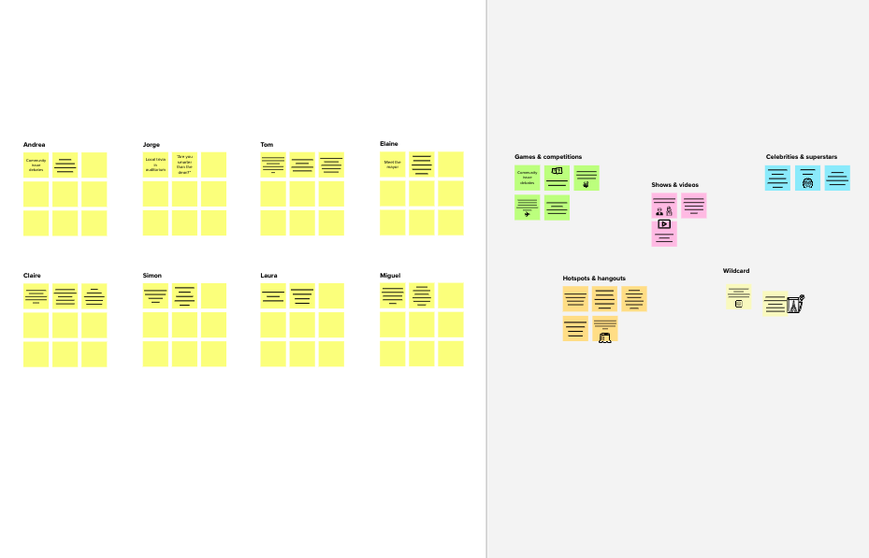

**Template**

**Need some inspiration?**

See a finished version of this template to kickstart your work.

[**Open example**](https://app.mural.co/template/e5a93b7b-49f2-48c9-afd7-a635d860eba6/93f1b98d-b2d2-4695-8e85-7e9c0d2fd9b9)